[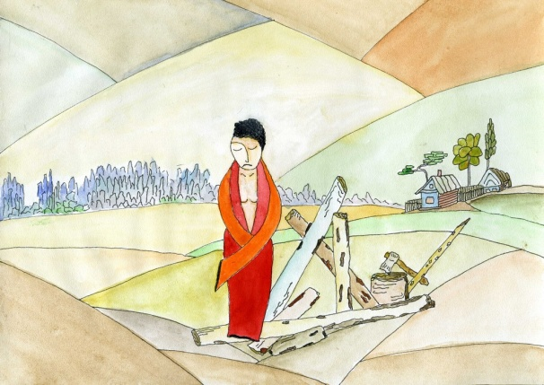](file:///D:\d\my_WEB\GALLERY\2015\April_07_2015\html\0\0\0\0002.html) [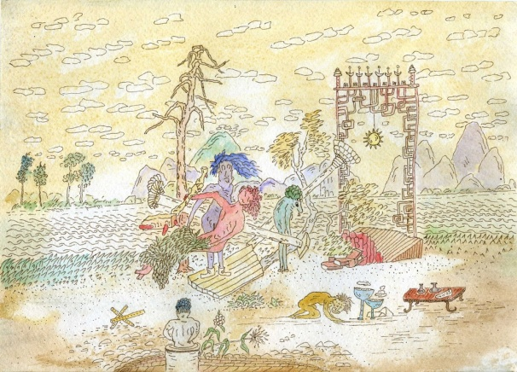](file:///D:\d\my_WEB\GALLERY\2015\05_02_2015\html\0\0\0\0000.html) [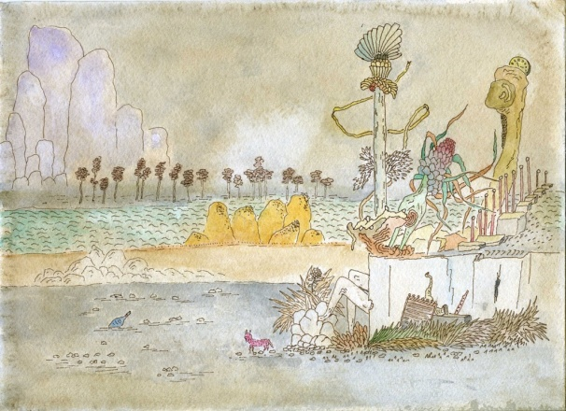](file:///D:\d\my_WEB\GALLERY\2015\30_01_2015\html\0\0\0\0000.html) [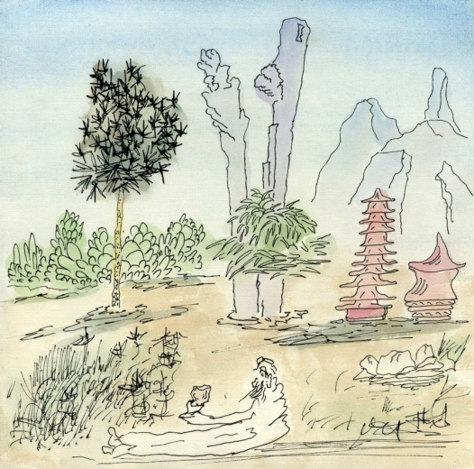](file:///D:\d\my_WEB\GALLERY\2016\06_25_26_cnt\html\0\0\0\0002.html)

[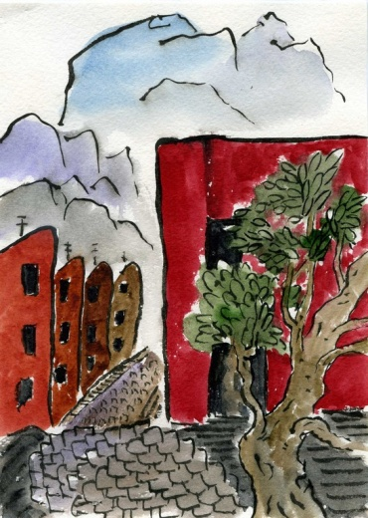](file:///D:\d\my_WEB\GALLERY\2015\23_01_2015\html\0\0\0\0000.html) [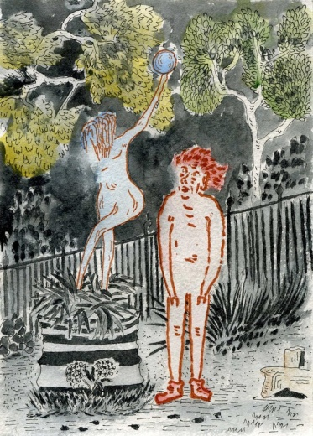](file:///D:\d\my_WEB\GALLERY\2015\17_01_2015\html\0\0\0\0000.html) [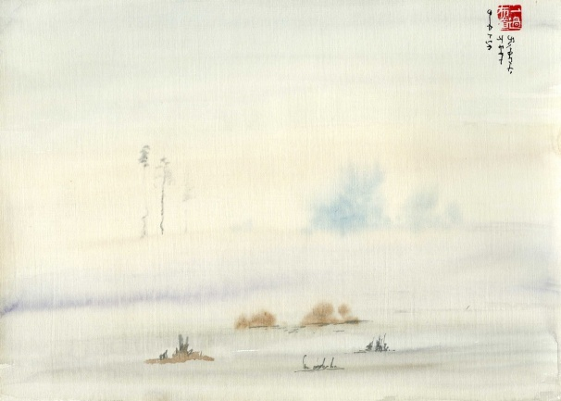](file:///D:\d\my_WEB\GALLERY\2016\02_21_22_cnt\html\0\0\0\0005.html) [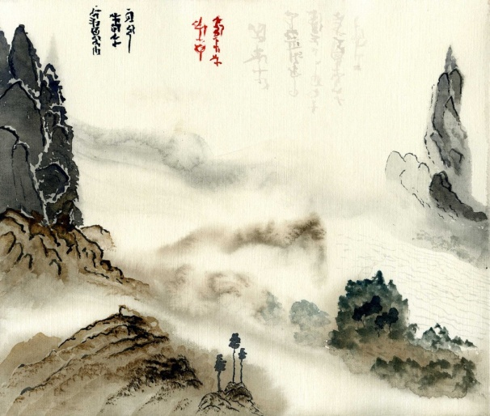](file:///D:\d\my_WEB\GALLERY\2016\05_14_15_cnt\html\0\0\0\0001.html)

[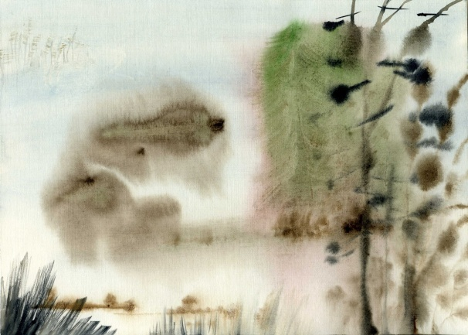](file:///D:\d\my_WEB\GALLERY\2016\05_8_9_cnt\html\0\0\0\0002.html) [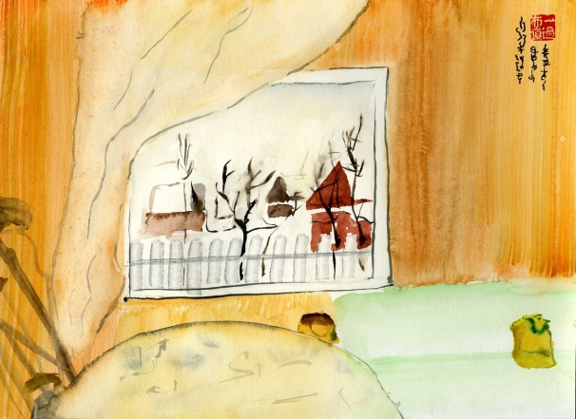](file:///D:\d\my_WEB\GALLERY\2016\02_21_22_cnt\html\0\0\0\0002.html) [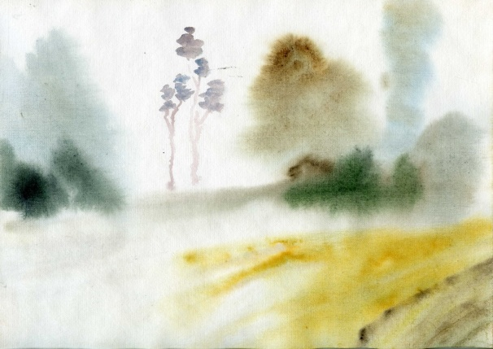](file:///D:\d\my_WEB\GALLERY\2015\Jule_24_25_2015_cnt\html\0\0\0\0000.html) [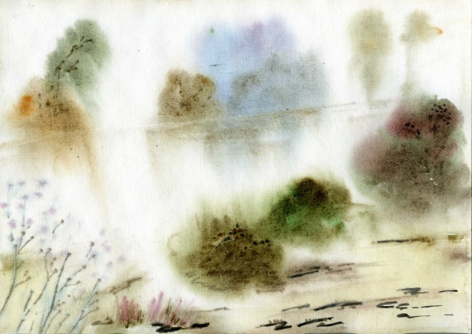](file:///D:\d\my_WEB\GALLERY\2015\Jule_24_25_2015_cnt\html\0\0\0\0001.html)