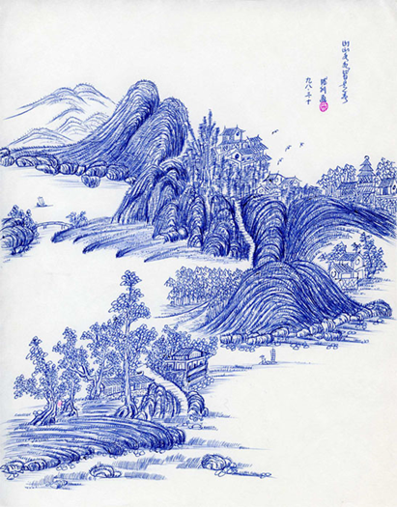
山山水水总是春

（平生第一幅圆珠笔画。办事和画画一样，要耐心细致，一丝不苟。）
（1998年）

Mountains and rivers are always in spring

This is the first ballpoint painting in my life. As painting, we should be patient and meticulous when we do anything.

（In 1998）

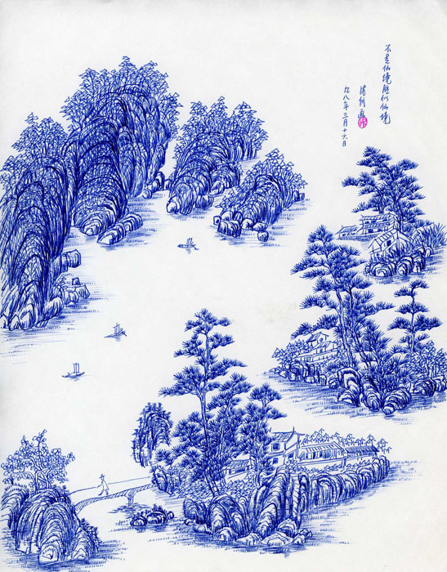
不是仙境胜似仙境

（平生第二幅圆珠笔画。性格恬淡，心胸开阔）
（In 1998）

It is not a fairyland but better than fairyland.

This is the second ballpoint pen painting in my life. I should have a quiet personality and an open mind.

（In 1998）

