画给伊戈尔先生
To Mr.Igor Burdonov

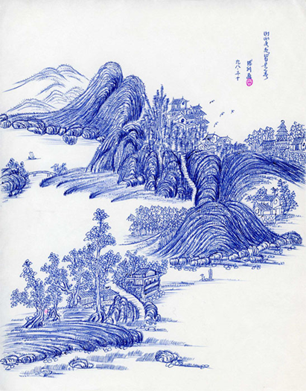

山山水水总是春
（平生第一、二幅圆珠笔画。）
宋德利作于1998年
Mountains and rivers are always in spring
First and second ballpoint pen paintings in my life.
By Song Deli in 1998

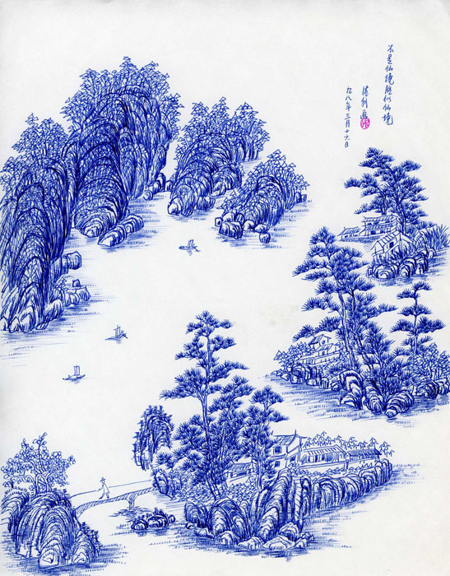

不是仙境胜似仙境
（平生第一、二幅圆珠笔画。）
宋德利作于1998年
Not fairyland is better than fairyland
Second ballpoint pen paintings in my life.
Song Deli in 1998
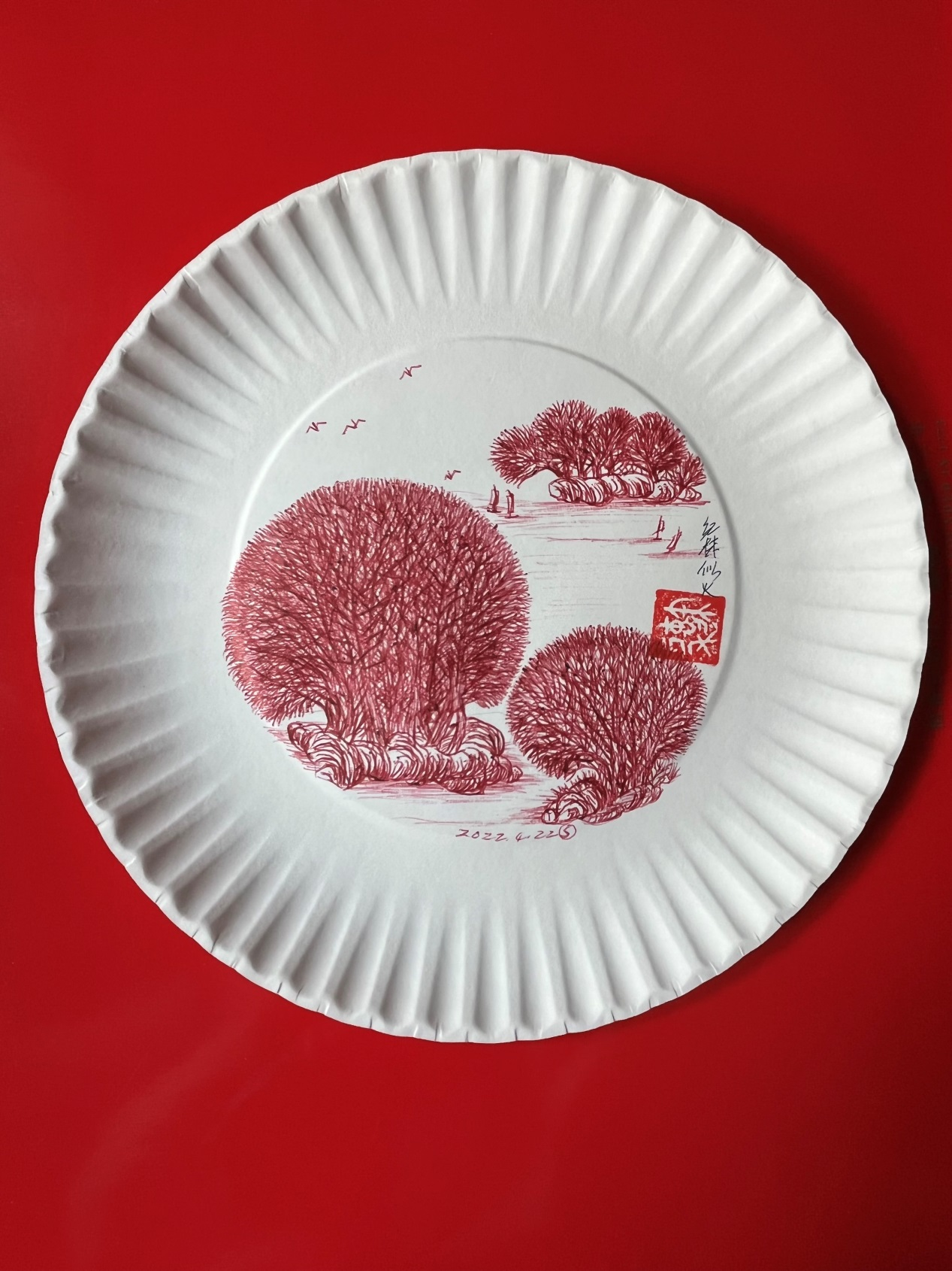
生机勃勃
（圆珠笔纸盘画）
Full of vitality
(Ball-point pen paper plate drawing)

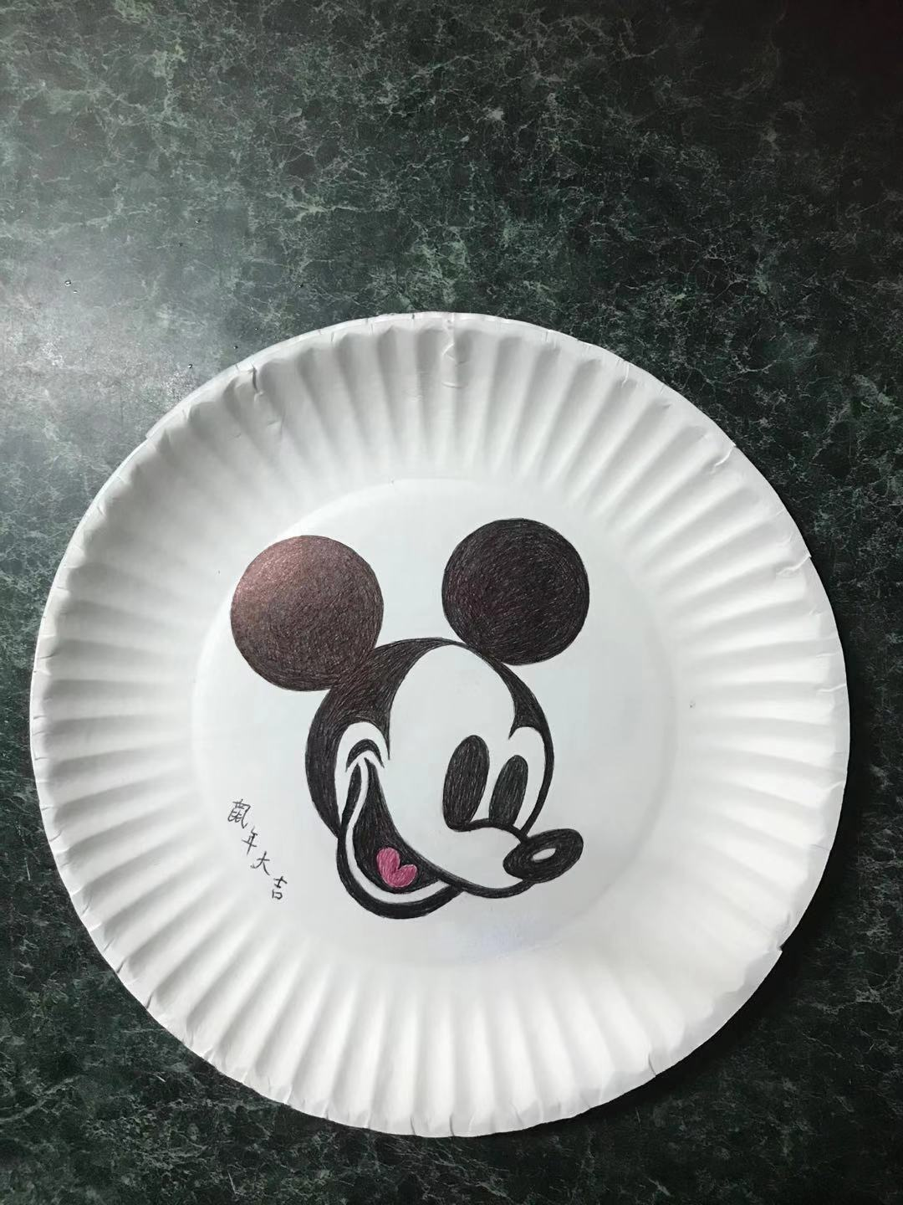
Ball-pointed pen drawing on paper plate
By Song Deli

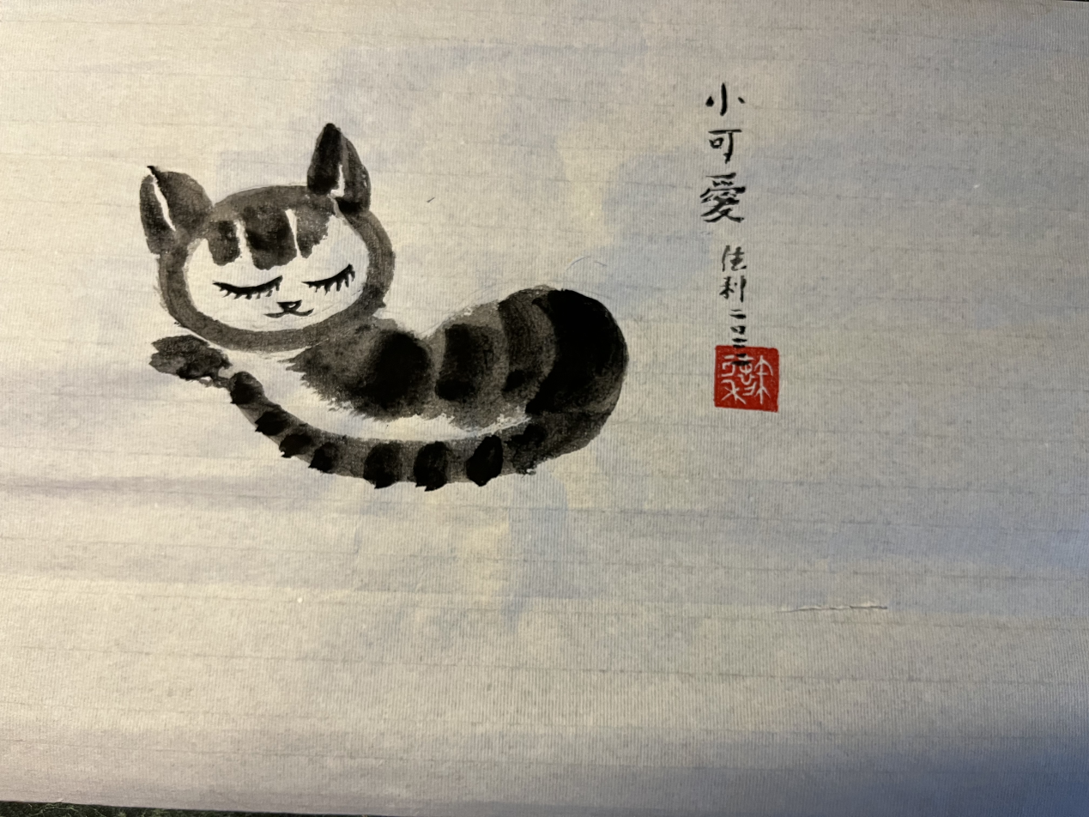
A little cat
Ink-brush painting
By Song Deli

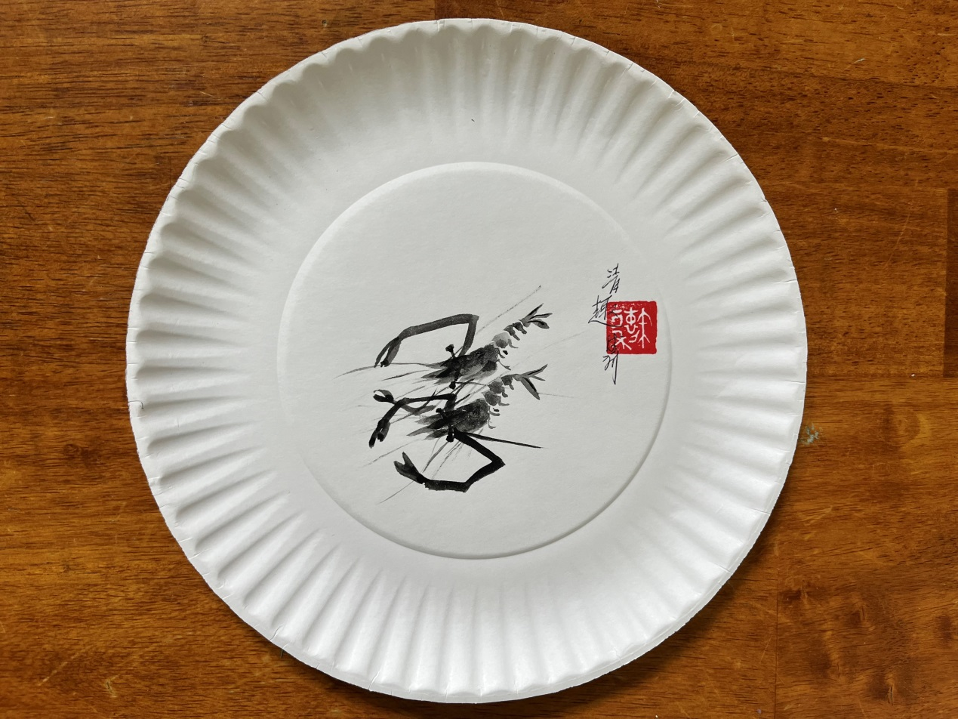Shrimps
Ink-brush painting
By Song Deli

图片2幅
Tow pictures

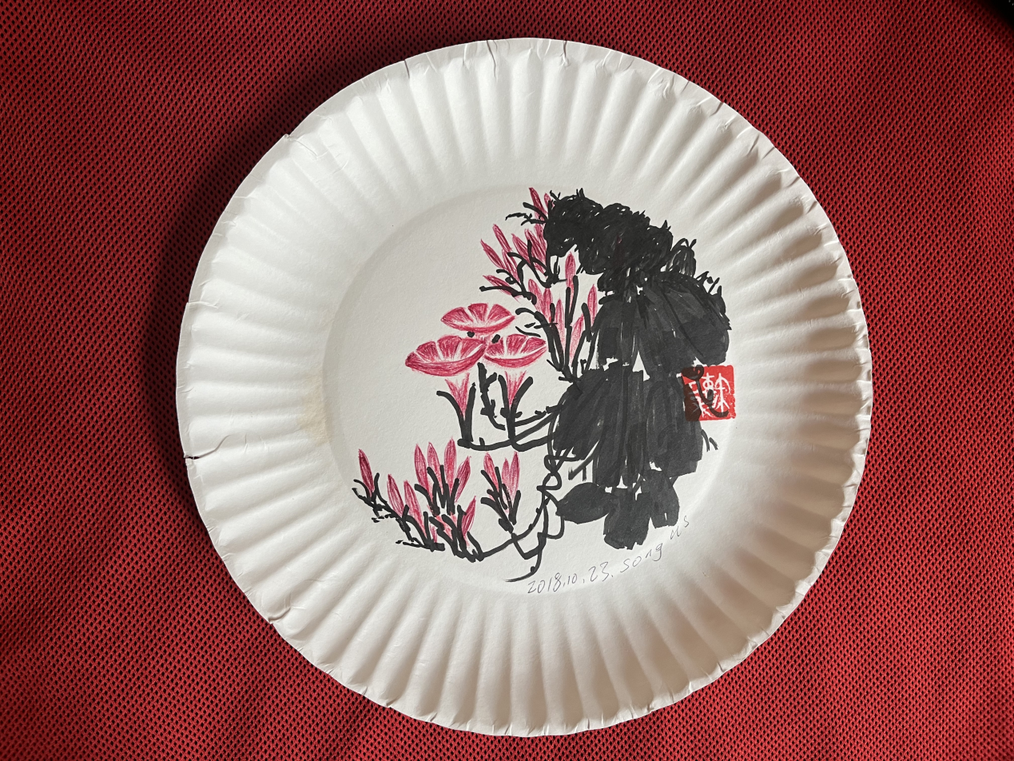
牵牛花（Morning glory）
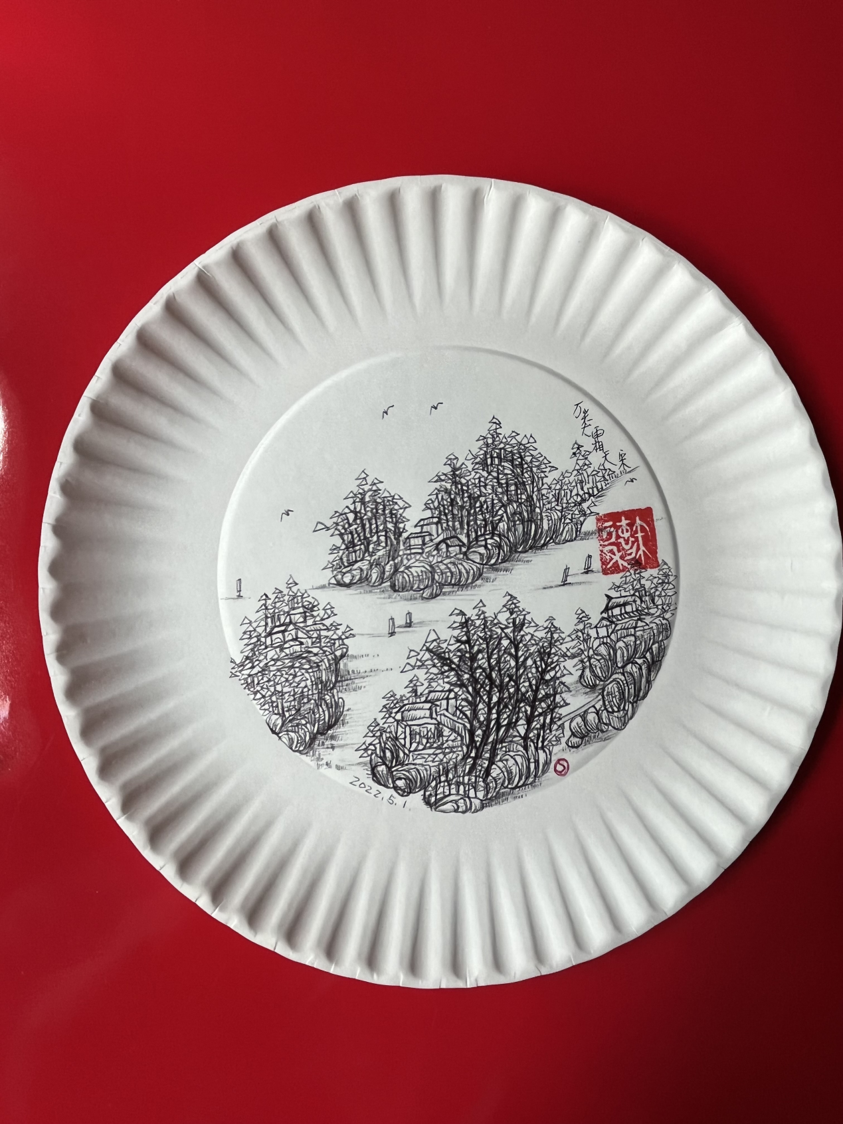
江山多娇（Beautiful landscape）

